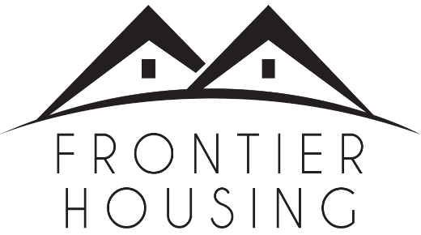

PRESS RELEASE

Friday, November 17, 2023

Contact: Stephanie Ockerman

Communications Manager

Frontier Housing

606-784-2131, x251

s.ockerman@frontierky.org

Frontier Housing Working to Get Access to Federal Grant Money for Hayswood Hospital Remediation

Morehead, KY - Frontier Housing is working to access the $1,999,900 Brownsfields Cleanup Grant it was awarded by the US Environmental Protection Agency (EPA). The grant will be used to remediate hazardous substance contamination at the Hayswood Hospital property in downtown Maysville.
While the award was made in May 2023, there is a lot of work that must be done before remediation work on the building can begin. Frontier and Buffalo Trace Area Development District have been working with the Regional EPA office to finalize the grant agreement. The next steps will be to procure an environmental engineering firm to lead the cleanup activities.

“Accessing federal grant funds is always an involved process, but we are working through it as quickly as the process allows,” stated Frontier Housing CEO Tom Manning-Beavin. He went on to say, “We appreciate all the help we are receiving from Buffalo Trace ADD and the EPA as we move forward.”
Frontier worked with city, county, and state officials, along with staff from Buffalo Trace Area Development District, to secure the funding. Frontier purchased the approximately 1.5-acre property in November 2022.
Frontier Housing is based in Morehead and serves 16 counties including Mason.
##
Frontier Housing is the leader for affordable housing solutions in Appalachian communities in the heart of the Ohio River Valley. Frontier improves the quality of life for individuals and families, helping them achieve long-term stability, financial independence, and generational wealth. Learn more at frontierky.org

