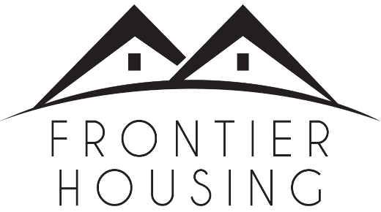

PRESS RELEASE

Monday, February 6, 2023

Contact: Stephanie Ockerman

Communications Manager

Frontier Housing

606-784-2131, x251

s.ockerman@frontierky.org

Frontier Housing to Construct 40-Unit Apartment Complex
Morehead, KY - Continuing its mission of developing affordable housing, Frontier Housing will construct a 40-unit multi-family apartment complex. Funding will come from federal and state programs that support projects for persons with low incomes and develop low-income rental housing through tax incentives.
Park View Apartments, to be located at 340 Triplett Street, across from the Sheltowee Falls Splash Pad and the Community Recycling Center, will be owned and developed by Frontier and the Housing Partnership of Louisville.
Park View Apartments will consist of one-bedroom, two-bedroom and three-bedroom units. There will be a community laundry facility, as well as washer/dryer hookups in each unit. A rental office and maintenance office will be located on site. In addition, there will be a playground area.
Heuser Hearing Institute of Louisville will have space in the development to provide services including diagnostics and assessments, as well as educational programs. These services will be provided to residents of Park View Apartments as well as members of the surrounding community.
Renters must meet eligibility requirements. Funding for the development was awarded through the Kentucky Housing Corporation’s (KHC) Affordable Housing Trust Fund (AHTF) and the federal Low-Income Housing Tax Credits Program. The AHTF supports projects that assist persons at or below 60 percent of the area median income. The Housing Credits program which is administered by the KHC promotes the development of low-income rental housing through tax incentives.
Frontier Housing has been clearing the path to homeownership since 1974. In that time, Frontier has assisted over 800 households become owners of newly constructed homes. Frontier serves the community in many ways: new home construction, mortgage lending, homeownership and credit advising, home repair & rehabilitation, and homes and apartments for rent.
##
Frontier Housing is the leader for affordable housing solutions in Appalachian communities in the heart of the Ohio River Valley. Frontier improves the quality of life for individuals and families, helping them achieve long-term stability, financial independence, and generational wealth.

